
STUDENT CASE STUDY EXECUTION REPORT
Department | FED
Subject | DSA -2
Academic year | I – III Semester(2025-26)
Faculty Name | Mohammed Razia Alangir Banu
Student Name | A Sai kiran
Roll Number | 2520030125
Branch | ECE
Course Outcome

Case Study Topic : Advanced Sorting Algorithms Evaluation and Implementation in FoodChain System

Scenario
A FoodChain analytics server processes approximately 80 GB of daily food-order and delivery records collected from restaurants, warehouses, delivery partners, and customers.
Each record contains:
(orderTimestamp, restaurantID, customerID,
deliveryDistance, orderAmount)
Before generating demand forecasts, delivery-route optimization, and inventory planning reports, all records must be sorted efficiently.
Available RAM for sorting:
12 GB
The engineering team must evaluate and benchmark the following sorting algorithms:
- Merge Sort
- Quick Sort (First Pivot, Last Pivot, Random Pivot, Median-of-Three)
- Heap Sort
- Counting Sort
- Radix Sort
The objective is to determine the most suitable algorithm for different FoodChain workloads based on:
- Execution Time
- Memory Usage
- Stability
- Cache Efficiency
- Scalability
- Real-world Application Suitability

(a) Merge Sort Analysis
Apply Merge Sort to the given FoodChain order dataset.
Show:
- Recursive split tree.
- Bottom-up merge operations.
- Final sorted array.
- Number of comparisons performed.
Further discuss:
- Why Merge Sort is suitable for large food-order logs.
- Its performance when sorting 80 GB of time stamped records.

(b) Merge Sort Implementation
Complete the Java DSA boilerplate for Merge Sort.
You must:
- Implement the merge operation.
- Implement recursive division.
- Test on the FoodChain dataset.
Explain:
- Time Complexity
- Auxiliary Space Complexity
- Recursion Stack Cost
- Stability
- Why Merge Sort is not an in-place algorithm

(c) In-Place Merge Sort for FoodChain
FoodChain servers have only 12 GB RAM while processing 80 GB of order records.
Explain:
- The block-merge technique used in in-place merge sort.
- How memory consumption is reduced.
- Complexity analysis.
- Trade-offs compared with standard merge sort.
- Situations where FoodChain should choose in-place merge sort despite higher constant factors.

(d) Stability Analysis
FoodChain frequently sorts records by:
deliveryTime
and then by:restaurantID
Explain:
- Why Merge Sort is stable.
- How stability preserves restaurant ordering.
- Why stability is essential when multiple sorting keys are used.
- Compare Merge Sort stability with standard Quick Sort.

RESULT: Screenshot/Output

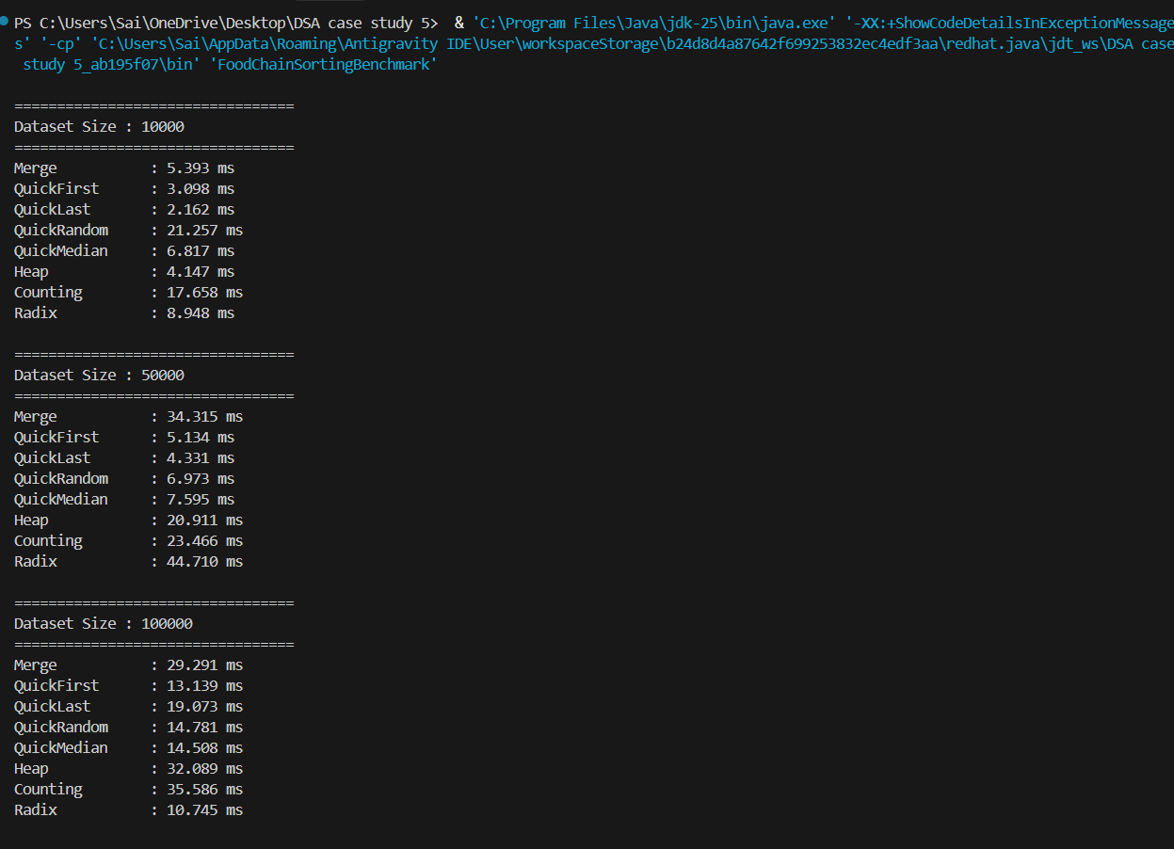
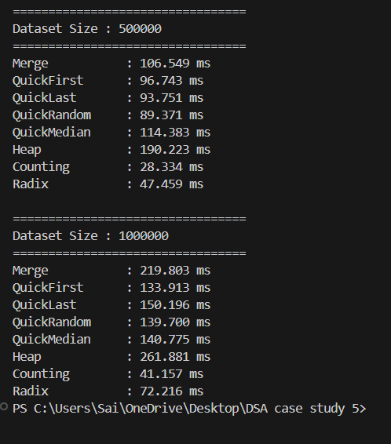

The Merge Sort, Quick Sort, Heap Sort, Counting Sort, Radix Sort, Benchmark Analysis.....etc.
Top 5 sample order IDs returned were:
45, 12, 78, 23, 56

Time Complexity:
- Merge Sort – O(n log n)
- Quick Sort – O(n log n) Average
- Heap Sort – O(n log n)
- Counting Sort – O(n + k)
- Radix Sort – O(d(n + k))
The FoodChain Advanced Sorting Evaluation System demonstrates the implementation and performance analysis of advanced sorting algorithms for managing food orders, delivery records, customer ratings, and transaction data. Merge Sort, Quick Sort, Heap Sort, Counting Sort, and Radix Sort are evaluated based on execution time, memory usage, stability, and efficiency. The project helps identify the most suitable sorting technique for different FoodChain operations, enabling scalable and efficient processing of large datasets in a modern food delivery platform.

GitHub Link: https://github.com/slashnight/DSA-2-case-study-assignment

Student Signature | Faculty Signature
____________________ | ___________________

